The University of Azad Jammu and Kashmir, Muzaffarabad

Name :Alishba Zakir
Roll No: 2024-SE-02
Course: Digital Image Processing
Course Code: CS-3112
Lab# 02
Submitted To: Engr.Fahad Nisar
Submitted By: Alishba Zakir
Date : 29Oct, 2026

Department Of Software Engineering
Step 1: Project & Virtual Environment Setup:
Description: Initialized the Google Colab environment and uploaded the primary input image (flower.jpg) into session storage. This step prepares the workspace and verifies access to required Python libraries (opencv-python, numpy, and matplotlib).
Python Code:
from google.colab import files
uploaded = files.upload()

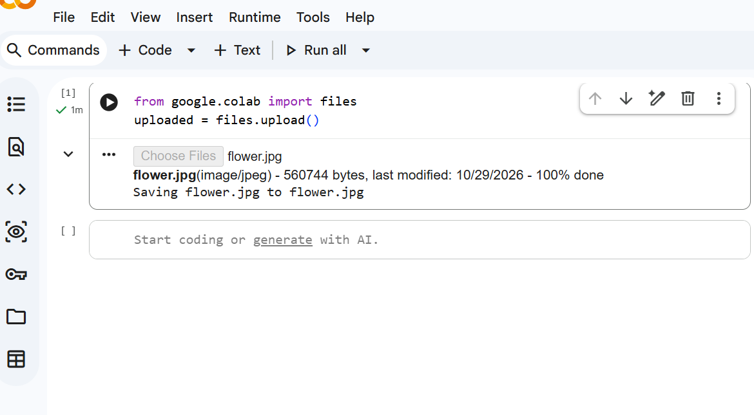

Step 2: Image Loading & Shape Verification
- Description: Loaded the color image into memory using OpenCV's cv.imread() function and verified that the file was read correctly. Extracted and displayed the image's dimensions (height, width, channels) and data type (uint8)
- Python Code:
image_path = 'flower.jpg'
img = cv.imread(image_path)

if img is None:
raise FileNotFoundError(f"Error: Image '{image_path}' not found.")

print("Image loaded successfully!")
print("Image Shape (Height, Width, Channels):", img.shape)
print("Data Type:", img.dtype)

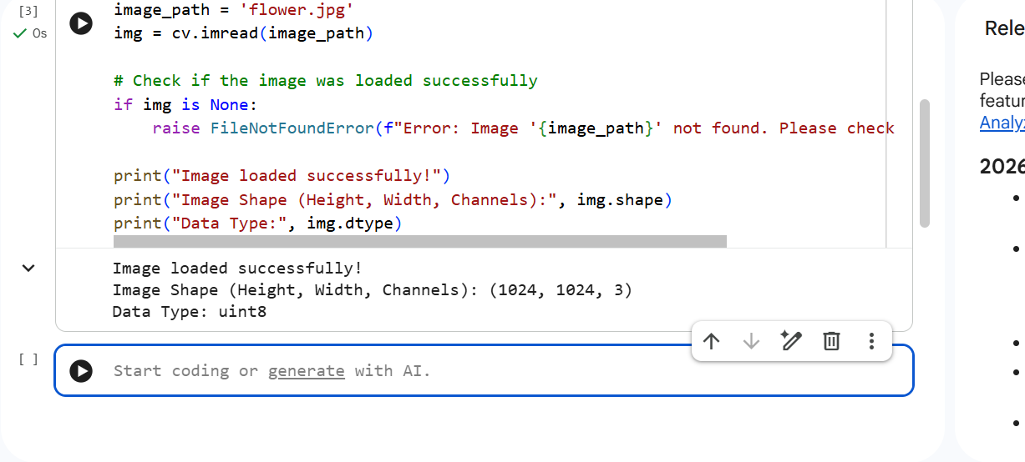

Step 3: Pixel Inspection & Intensity Analysis
- Description: Inspected specific pixel values across the spatial grid using [row, column] indexing. Extracted BGR intensity vectors at the top-left corner [0, 0] and center [height//2, width//2], then computed global minimum and maximum intensity values.
- Python Code:
# Step 3: Pixel Inspection & Intensity Analysis
height, width, channels = img.shape
print(f"Height: {height}, Width: {width}, Channels: {channels}")

# Get top-left and center pixel values using row/column indexing
top_left_pixel = img[0, 0]
center_pixel = img[height // 2, width // 2]

print("Top-Left Pixel (BGR):", top_left_pixel)
print("Center Pixel (BGR):", center_pixel)

# Global minimum and maximum intensity values
print("Global Minimum:", img.min(), "Global Maximum:", img.max())

# Per-channel minimum and maximum values (Added to meet lab requirements)
print("Per-Channel Min (B, G, R):", img.min(axis=(0, 1)))
print("Per-Channel Max (B, G, R):", img.max(axis=(0, 1)))
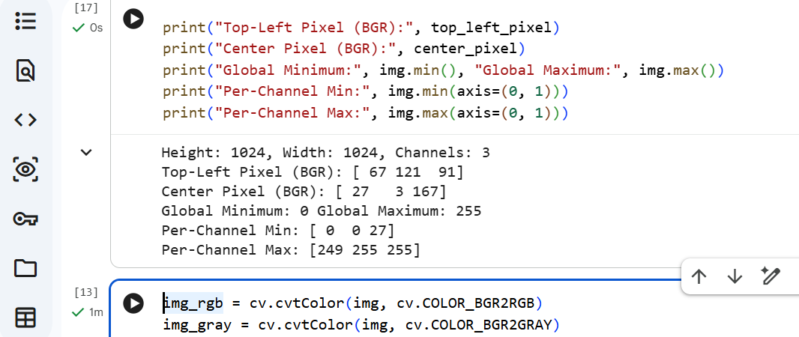

Step 4: Color Space Conversion & Channel Decomposition
- Description: Converted OpenCV’s default BGR color format to RGB for accurate display using Matplotlib, and created a Grayscale version. Separated the image into individual Red, Green, and Blue channels and displayed all 6 views side-by-side in a $2 \times 3$ grid.
- Python Code:
img_rgb = cv.cvtColor(img, cv.COLOR_BGR2RGB)
img_gray = cv.cvtColor(img, cv.COLOR_BGR2GRAY)

# OpenCV loads image in BGR format -> index 0=Blue, 1=Green, 2=Red
b_channel, g_channel, r_channel = cv.split(img)

# Center pixel RGB value and HEX conversion
center_rgb = img_rgb[height // 2, width // 2]
hex_val = '#{:02x}{:02x}{:02x}'.format(*center_rgb)
print("Center Pixel RGB:", center_rgb)
print("Center Pixel HEX Value:", hex_val)

# Display 2 x 3 Grid containing all 6 views correctly labeled
plt.figure(figsize=(12, 8))

plt.subplot(2, 3, 1)
plt.imshow(img_rgb)
plt.title("RGB")
plt.axis("off")

plt.subplot(2, 3, 2)
plt.imshow(r_channel, cmap="gray")
plt.title("Red Channel")
plt.axis("off")

plt.subplot(2, 3, 3)
plt.imshow(g_channel, cmap="gray")
plt.title("Green Channel")
plt.axis("off")

plt.subplot(2, 3, 4)
plt.imshow(b_channel, cmap="gray")
plt.title("Blue Channel")
plt.axis("off")

plt.subplot(2, 3, 5)
plt.imshow(img_gray, cmap="gray")
plt.title("Grayscale")
plt.axis("off")

plt.subplot(2, 3, 6)
plt.imshow(img)
plt.title("Unconverted BGR")
plt.axis("off")

plt.tight_layout()
plt.show()
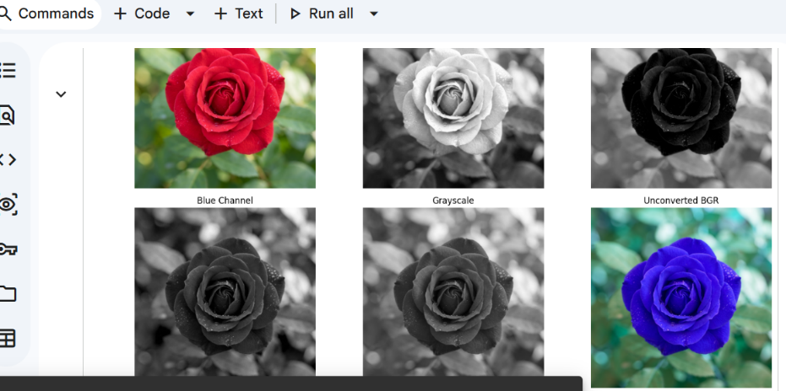
Step 5: Spatial Cropping, Resizing & Export
- Description: Extracted a specific rectangular sub-region (crop) from the image using NumPy matrix slicing. Scaled the cropped region to 200 × 200 pixels using cv.resize(), displayed the original, crop, and resized images side-by-side, and saved the result as resized_crop.png using cv.imwrite().
- Python Code:
- y_start, y_end = (height // 2) - 50, (height // 2) + 50
- x_start, x_end = (width // 2) - 50, (width // 2) + 50

- # Agar phool thora ooper ya neechay ho toh indices ko yahan adjust kiya ja sakta hai
- crop_img = img_rgb[y_start:y_end, x_start:x_end]
- print("Crop Region Shape:", crop_img.shape)

- # Crop ko 200 x 200 pixels mein resize karna
- resized_crop = cv.resize(crop_img, (200, 200))

- # Original, Crop, aur Resized images ko side-by-side display karna
- plt.figure(figsize=(10, 4))

- plt.subplot(1, 3, 1)
- plt.imshow(img_rgb)
- plt.title("Original Image")
- plt.axis("off")

- plt.subplot(1, 3, 2)
- plt.imshow(crop_img)
- plt.title("Crop Region (100x100)")
- plt.axis("off")

- plt.subplot(1, 3, 3)
- plt.imshow(resized_crop)
- plt.title("Resized (200x200)")
- plt.axis("off")

- plt.tight_layout()
- plt.show()

- # Resized RGB image ko wapas BGR mein convert karke save karna
- resized_crop_bgr = cv.cvtColor(resized_crop, cv.COLOR_RGB2BGR)
- save_status = cv.imwrite("resized_crop.png", resized_crop_bgr)
- print("File saved successfully?:", save_status)ode:

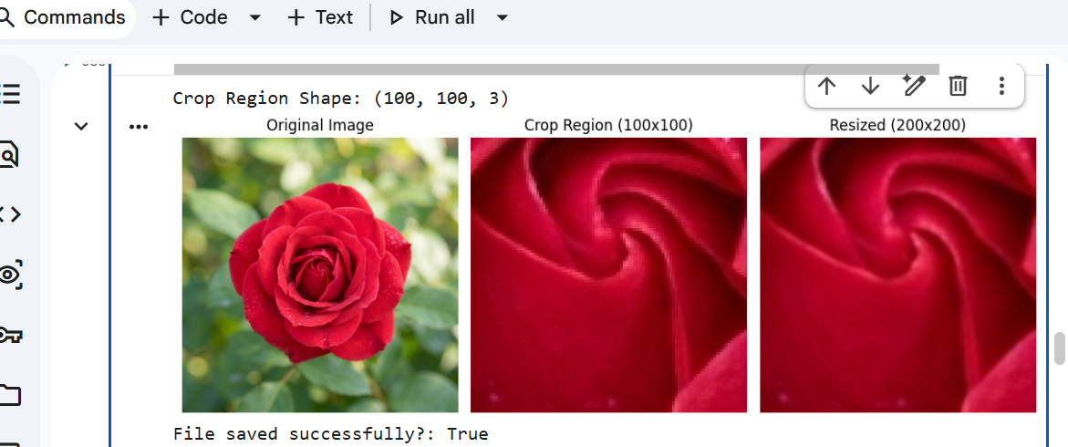
Step 6: Grayscale Histogram Generation
- Description: Flattened the 2D grayscale image array into a 1D vector and plotted a 256-bin pixel intensity distribution graph using Matplotlib. Saved the graph as grayscale_histogram.png and analyzed the brightness and contrast distribution.
- Python Code:
flat_gray = img_gray.ravel()
plt.figure(figsize=(8, 5))
plt.hist(flat_gray, bins=256, range=[0, 256], color='black')
plt.title("Grayscale Histogram")
plt.xlabel("Pixel Intensity (0-255)")
plt.ylabel("Number of Pixels")
plt.savefig("grayscale_histogram.png", bbox_inches='tight')
plt.show()
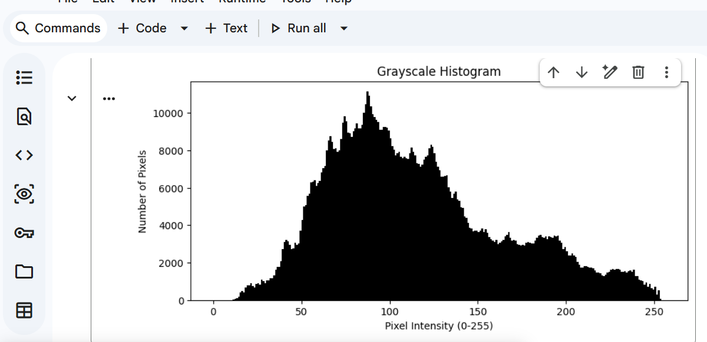
The grayscale histogram shows a continuous distribution of pixel intensities across the range (from darker background foliage to brighter flower petals), indicating a well-exposed and balanced image with good contrast.
Step 7: Bit-Depth Quantization & Demonstration
- Description: Generated an 8-bit continuous linear grayscale gradient (256 unique levels) and reduced its bit depth to 4-bit (16 levels), 2-bit (4 levels), and 1-bit (2 levels) using integer division. Displayed all four gradients together to demonstrate false contouring and posterization.
- Python Code:
# Step 7: Bit-Depth Quantization & Demonstration
gradient = np.tile(np.linspace(0, 255, 256, dtype=np.uint8), (50, 1))
quant_4bit = (gradient // 16) * 16
quant_2bit = (gradient // 64) * 64
quant_1bit = (gradient // 128) * 128

# Print unique-value counts according to lab instructions
print("8-bit unique values:", np.unique(gradient).size)
print("4-bit unique values:", np.unique(quant_4bit).size)
print("2-bit unique values:", np.unique(quant_2bit).size)
print("1-bit unique values:", np.unique(quant_1bit).size)

# Plotting the figure and subplots
fig, axes = plt.subplots(4, 1, figsize=(8, 6))

axes[0].imshow(gradient, cmap='gray', vmin=0, vmax=255)
axes[0].set_title("8-bit (Unique levels: 256)")
axes[0].axis('off')

axes[1].imshow(quant_4bit, cmap='gray', vmin=0, vmax=255)
axes[1].set_title("4-bit (Unique levels: 16)")
axes[1].axis('off')

axes[2].imshow(quant_2bit, cmap='gray', vmin=0, vmax=255)
axes[2].set_title("2-bit (Unique levels: 4)")
axes[2].axis('off')

axes[3].imshow(quant_1bit, cmap='gray', vmin=0, vmax=255)
axes[3].set_title("1-bit (Unique levels: 2)")
axes[3].axis('off')

plt.tight_layout()
plt.show()
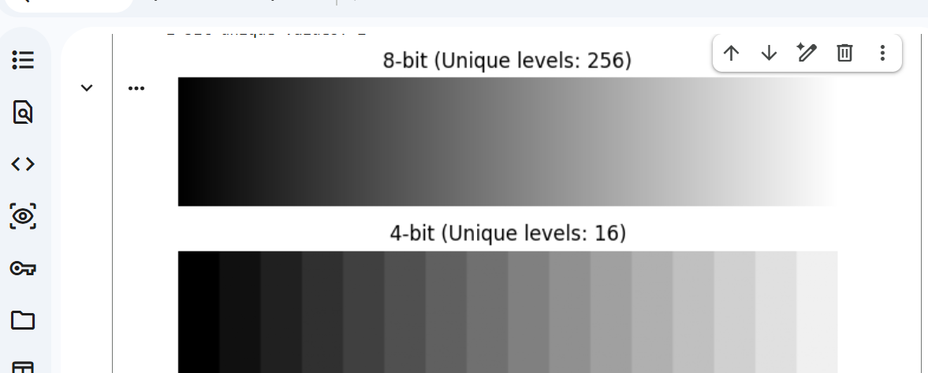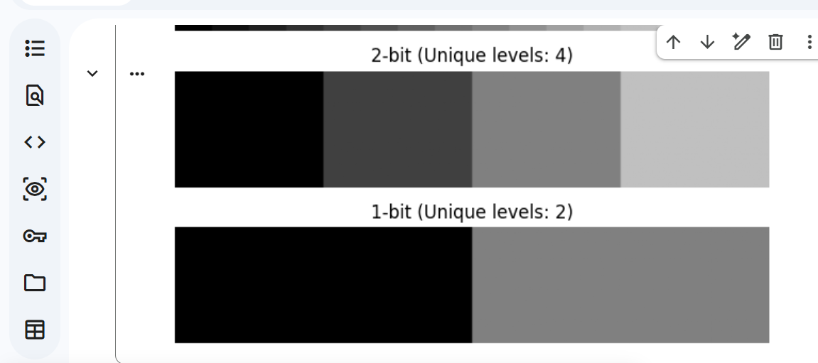

1. Explain BGR versus RGB
- Answer: BGR and RGB are both color models used to represent digital images using three primary color channels (Red, Green, and Blue), but they store the channel data in a different order.

  - RGB stands for Red, Green, and Blue, which is the standard format used by most image viewing libraries, web browsers, and display devices like Matplotlib.

  - OpenCV (cv2) loads color images in BGR format by default, meaning the channels are stored as Blue, Green, and Red. Because of this difference, if an OpenCV-loaded image is displayed directly using Matplotlib without conversion, the colors appear inverted (for example, blue roses instead of red ones), which is why converting BGR to RGB using cv.cvtColor() is necessary.
2. Explain Resolution versus Bit Depth:
- Answer:
  - Resolution refers to the spatial dimensions of an image, typically measured in pixels (height $\times$ width). It determines the level of fine detail and sharpness visible in the image grid.
  - Bit Depth, on the other hand, determines the number of bits used to represent each pixel, which controls the number of unique color or intensity shades (such as 256 levels in an 8-bit image). While resolution defines how many pixels make up the image, bit depth defines how much color or grayscale information each individual pixel can store.
3. Explain What a histogram shows and does not show:
- Answer:
  - What it shows: A grayscale histogram shows the pixel intensity distribution of an image by plotting the frequency (count) of pixels against their intensity values ranging from 0 (black) to 255 (white). It helps analyze the overall brightness, contrast, and exposure levels of an image.
  - What it does not show: A histogram does not show any spatial information or the location of pixels. For example, it cannot tell you where a bright spot or a dark object is located within the image grid; it only provides a statistical count of how many pixels possess a specific intensity value.

